**3. Create a DocumentDB Cluster parameter Group and Enable and Disable the Profile Value and other parameter value and Export the Audit Logs and Profiler Logs in in Cloud Watch Log groups**

Step1:

Create DocumentDb instance

Name: for assignment2c

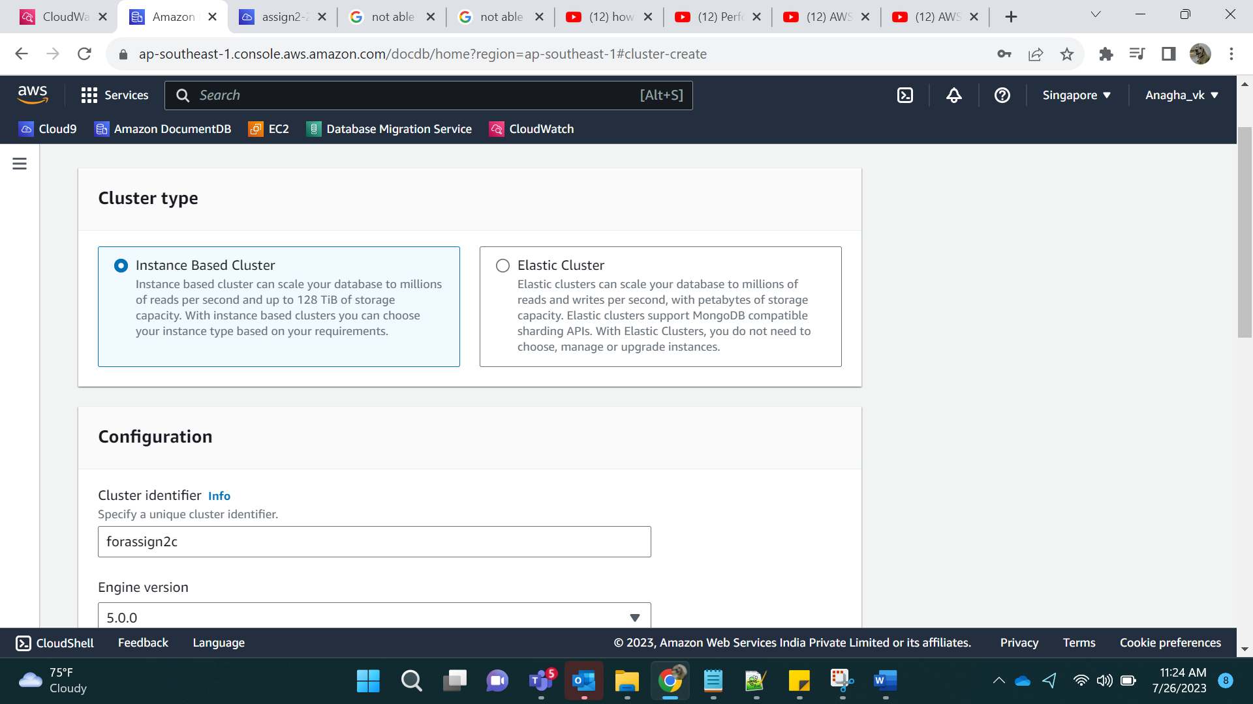

No of instances: 1

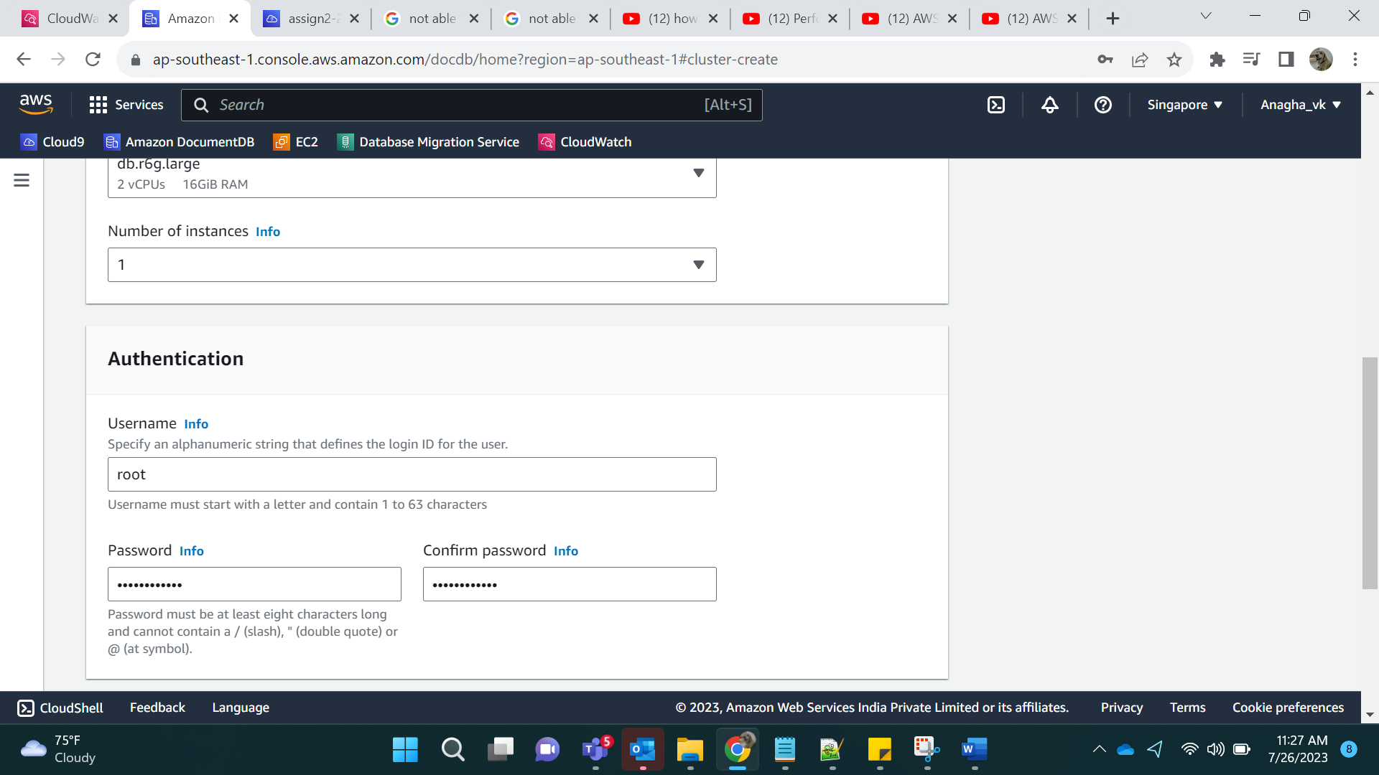

In Advance settings, click on Audit logs and Profiler Logs.

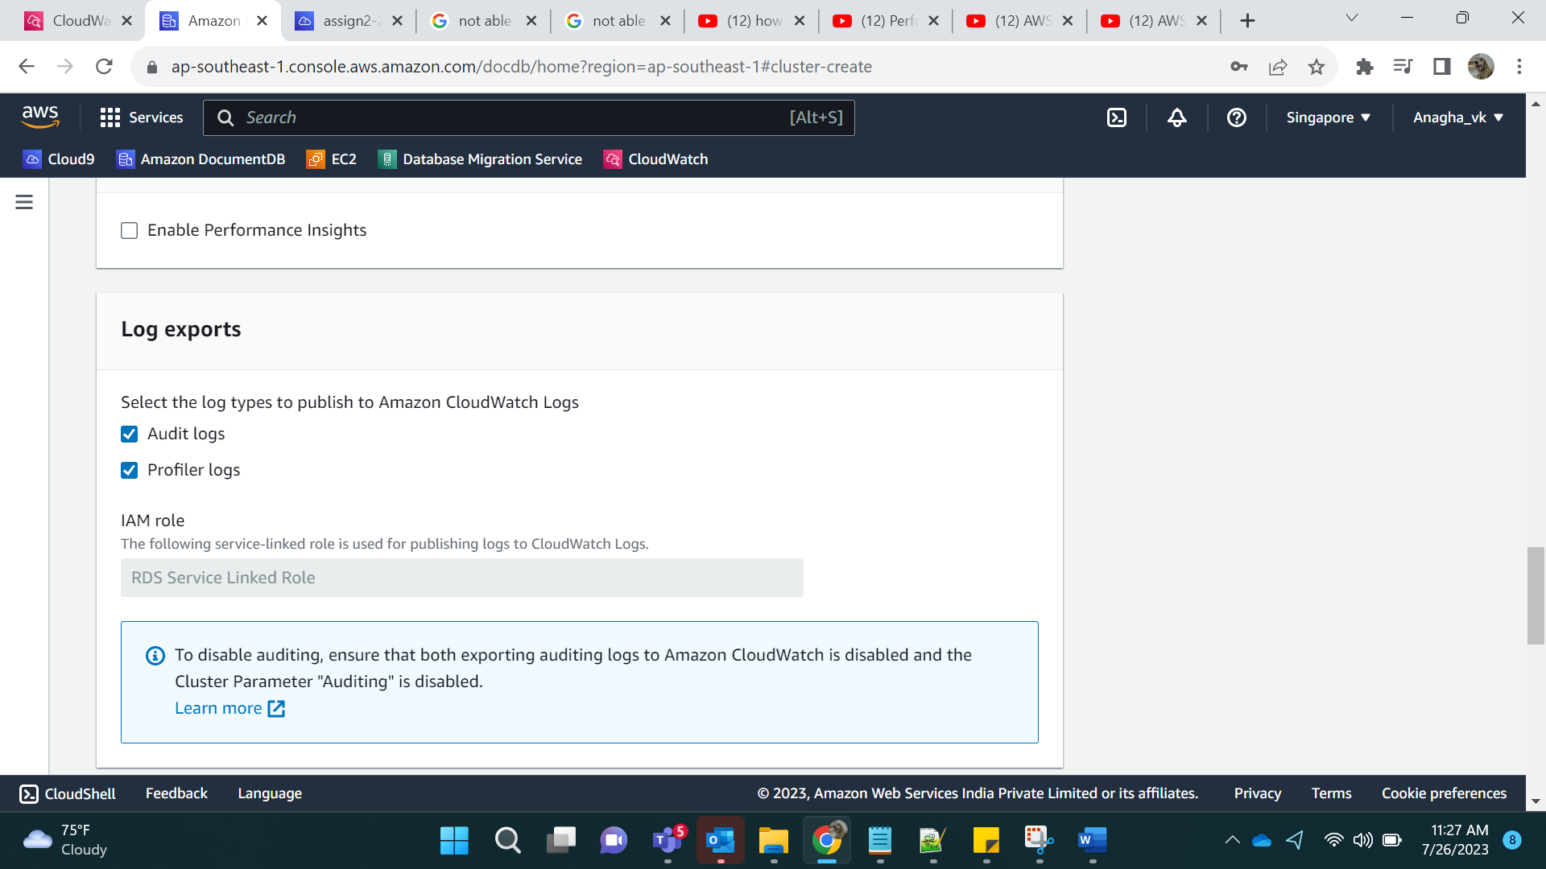

Click on Create.

In Parameter Groups, Create parameter group for the docdb Instance.

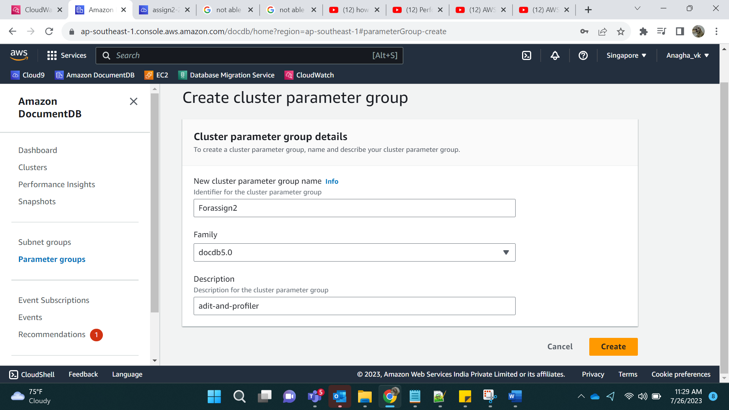

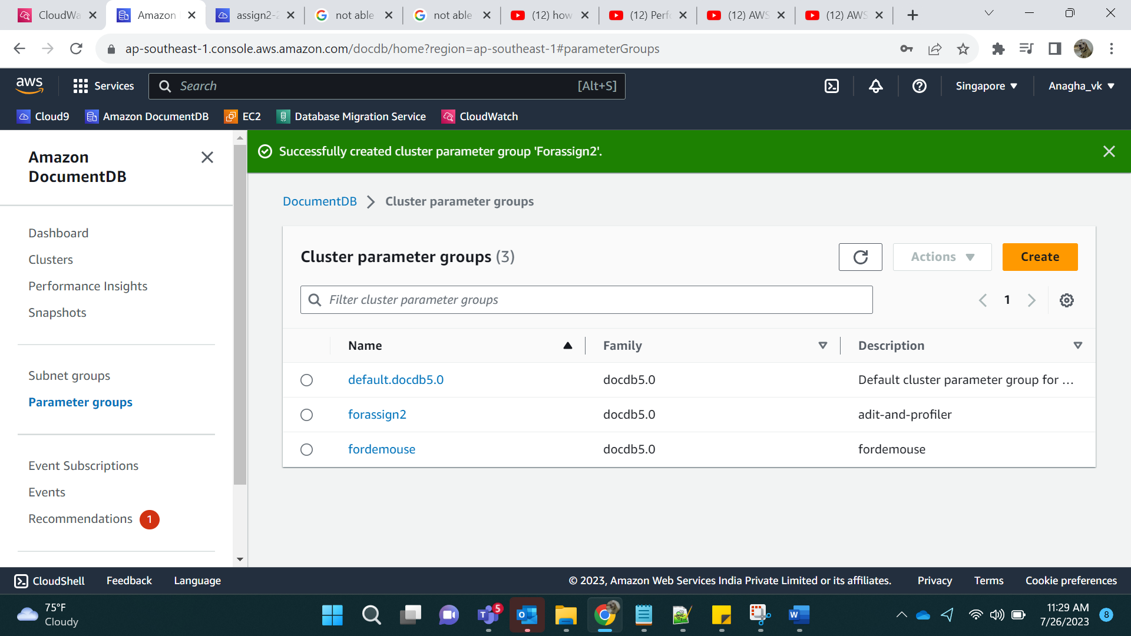

Step 2:

We need to attach the cluster parameter group to Docdb instance. Modify the DocDB cluster and attach the cluster parameter group.

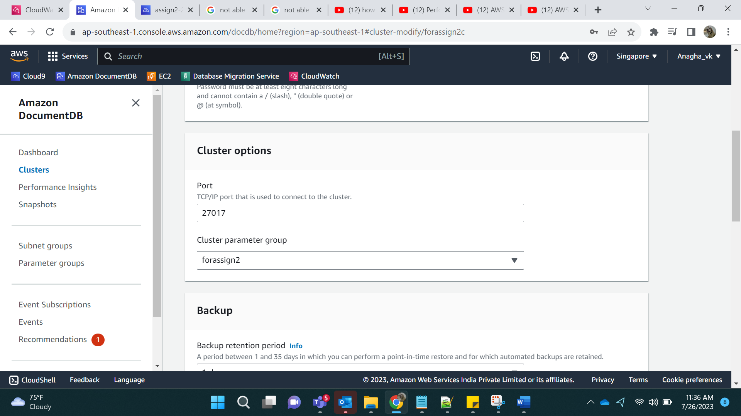

Step 3: In Cluster parameter groups, we need to change a few parameters,

Before Edit:

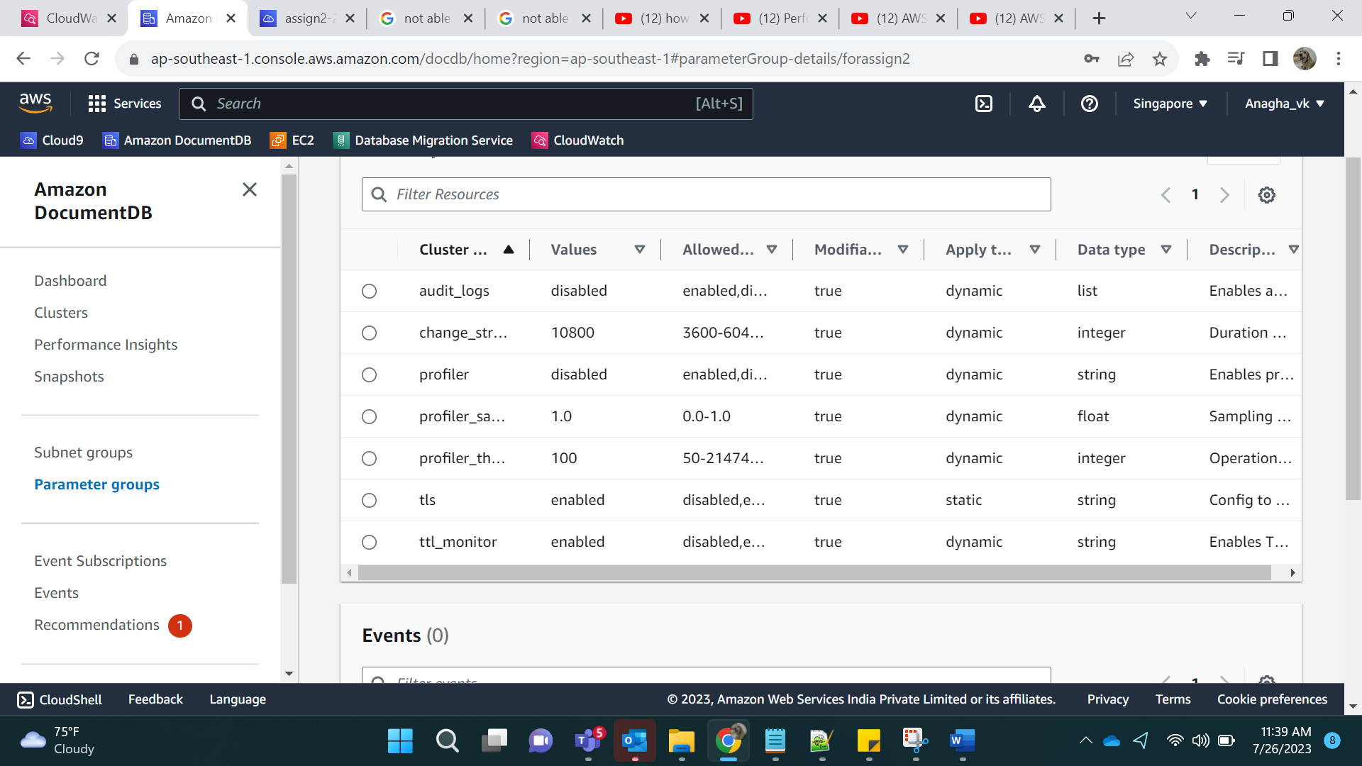

We enable the profiler, enable audit logs, profiler_threshold_ms to 50.

After Edit:

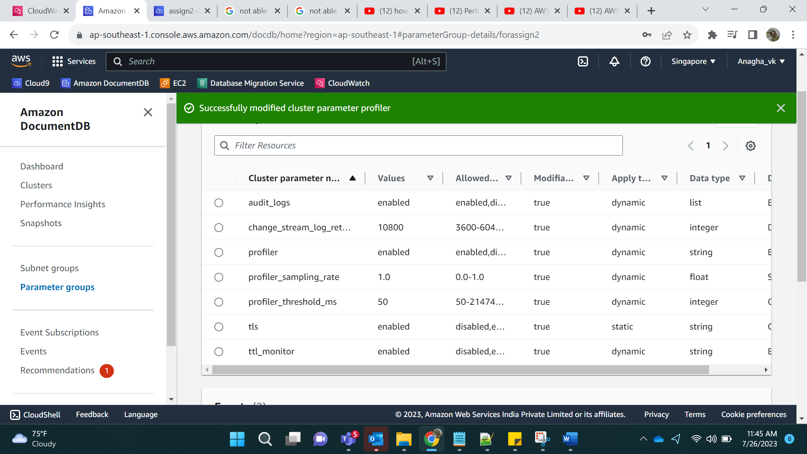

Step 4:

Post this,

Try logging into the instance:

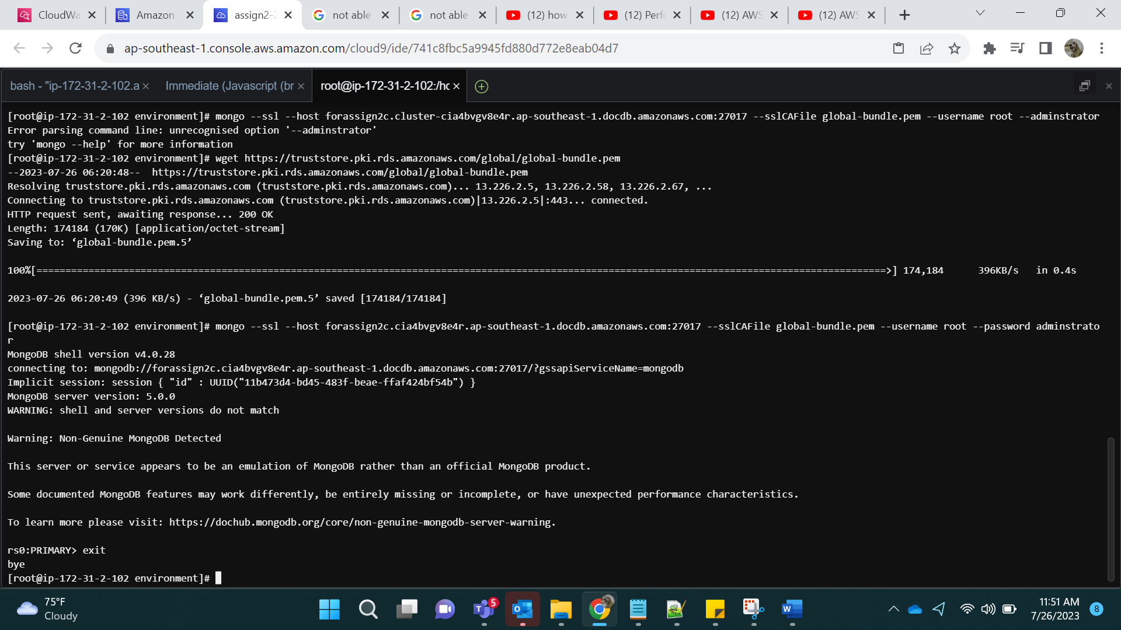

Later, go to CloudWatch and Log Groups, we can see the AUDIT logs as follows:

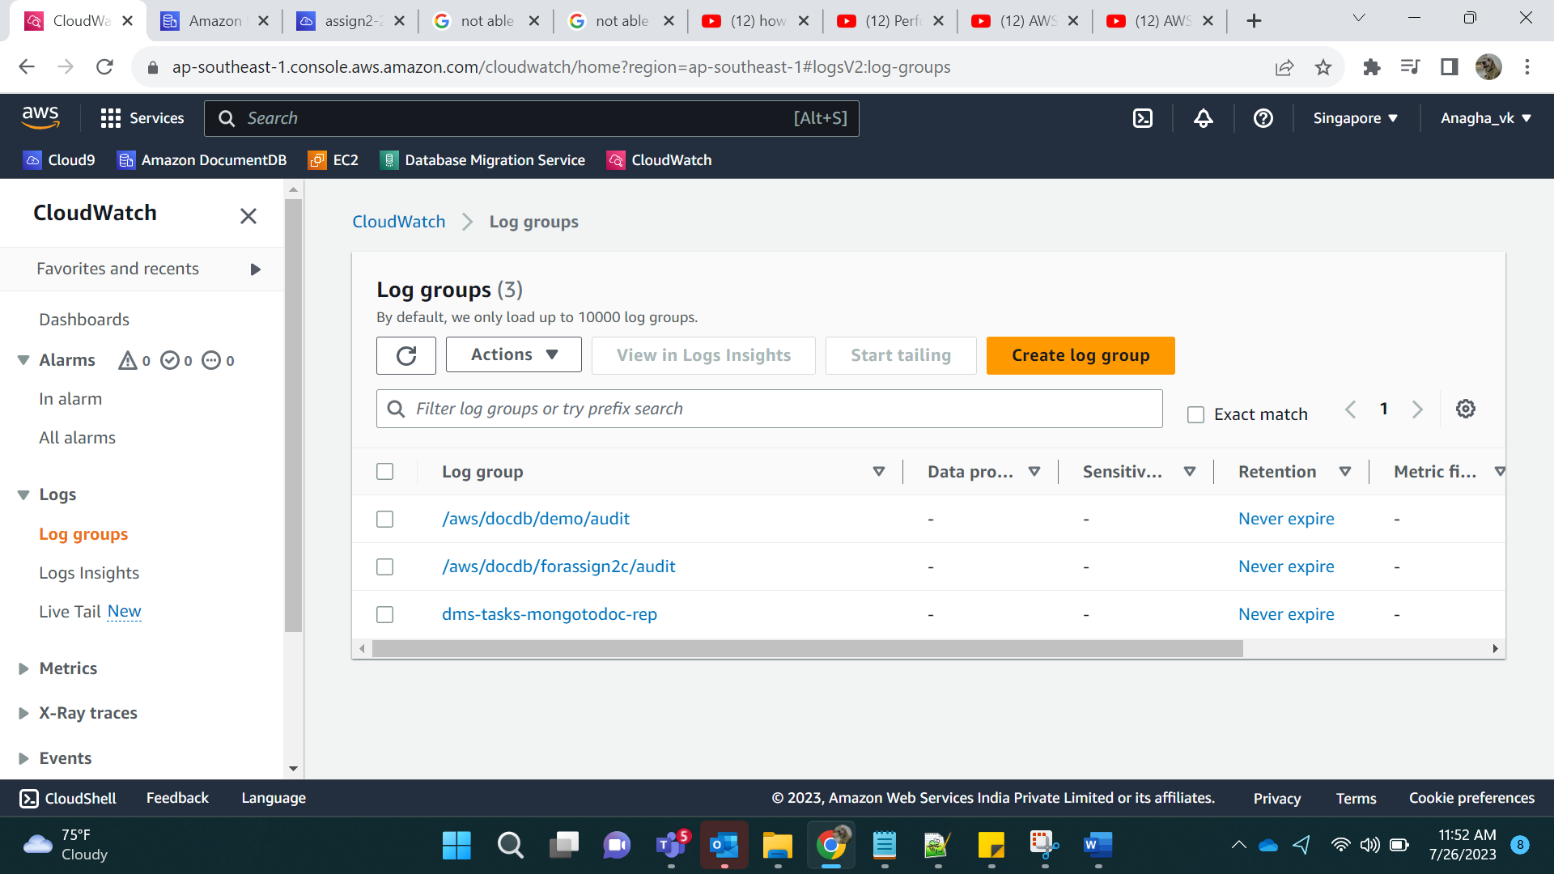

Click on the audit folder.

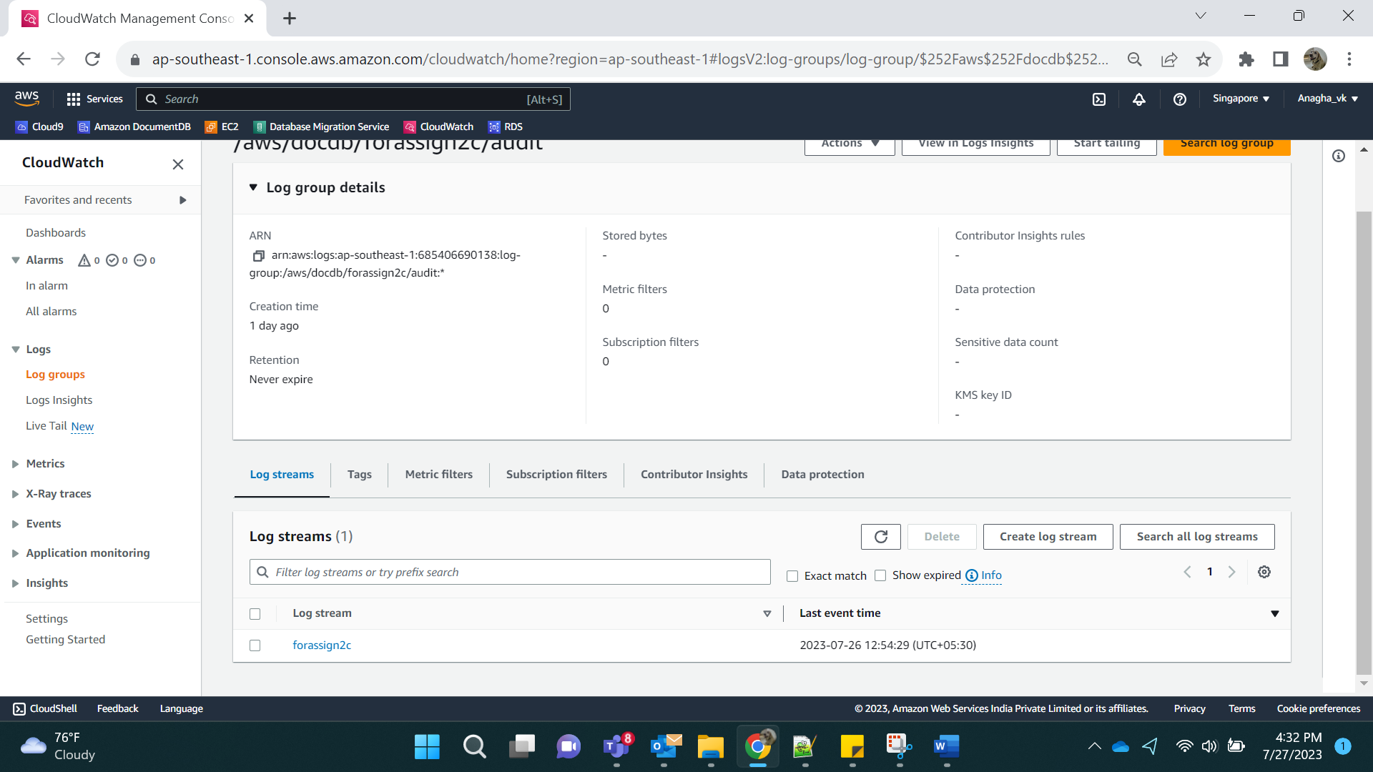

On clicking forassign2c we can see the Audit Logs

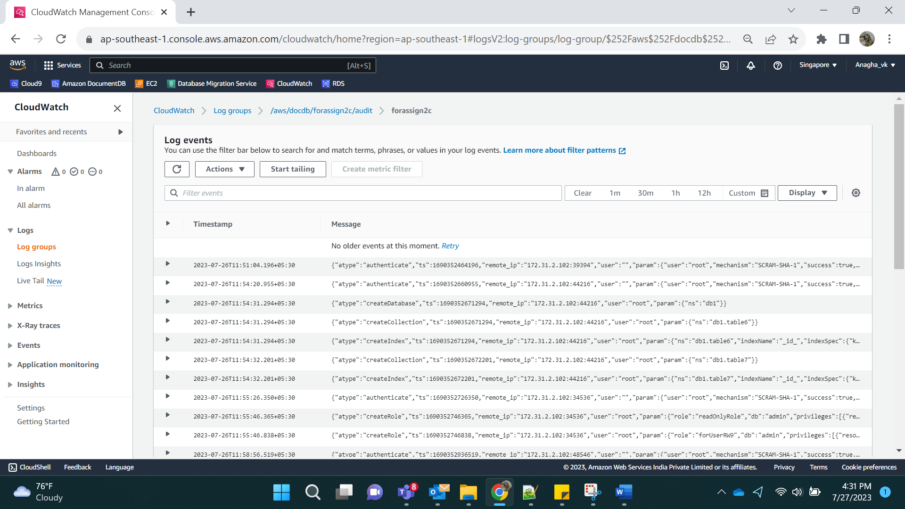

Step 5:

For Profiler Logs, we need to add data:

Download the dataset with the following code:

wget -O cases.json https://raw.githubusercontent.com/aws-samples/amazon-documentdb-samples/master/datasets/cases.json

Load the dataset using mongoimport

mongoimport --ssl --host forassign2c.cluster-cia4bvgv8e4r.ap-southeast-1.docdb.amazonaws.com:27017 --sslCAFile global-bundle.pem --username root --password adminstrator --collection=daily_cases --db=testdb --file=cases.json

Login :

mongo --ssl --host forassign2c.cluster-cia4bvgv8e4r.ap-southeast-1.docdb.amazonaws.com:27017 --sslCAFile global-bundle.pem --username root --password adminstrator

Run the following commands:

db.daily_cases.find({"Cases": 1068})

db.daily_cases.aggregate([{ $match: { Cases: { $gte: 100, $lt: 1000 } }}, { $group: { _id: null, count: { $sum: 1 } } } ]);

This will process some data in DocumentDB.

We can find profiler folder in Cloud Watch:

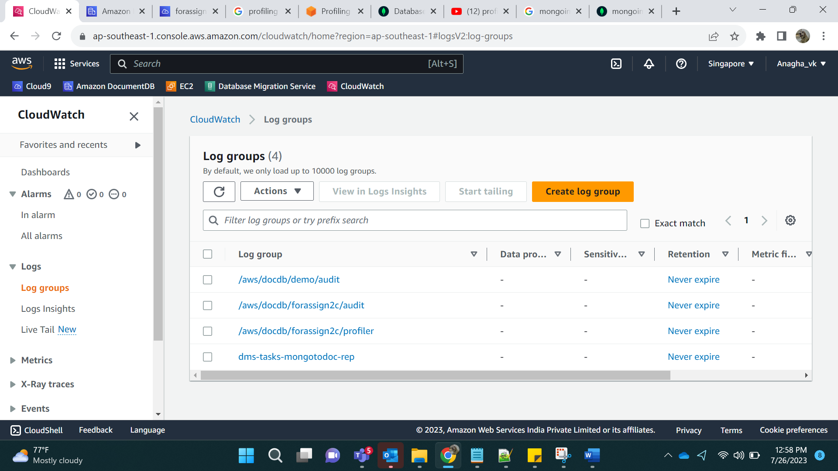

Click on the profiler folder

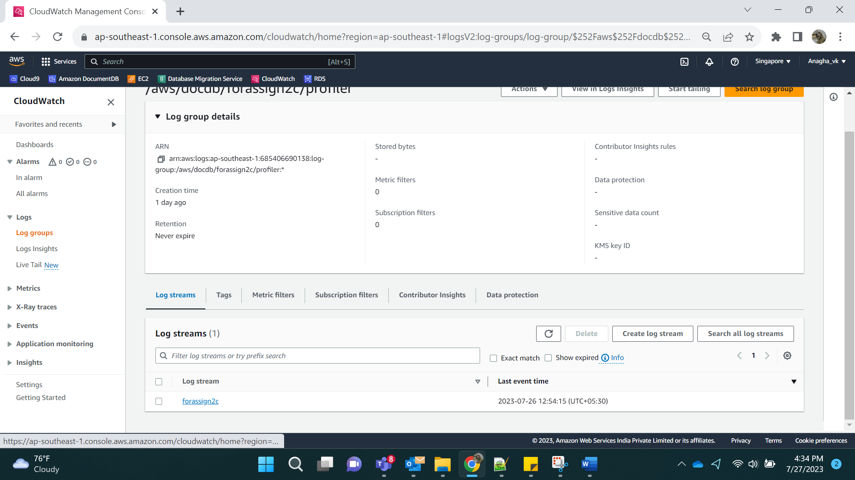

Click on forassign2 Profiler Logs

